Documentation: Error Trapping and Error Messages

Preventing input errors is always a key application requirement. For example, if an end user wants to find a particular record, an incorrect parameter entry yields no records at all. In some cases, the “no record” output will simply produce a blank output line. In other cases, a “no record” condition yields errors in the output presentation. The latter scenario is likely in a report, which then identifies all output nulls as #Error. To say the least, such an output is likely to be disturbing to an end user, so it’s best to produce input controls that trap incomplete or incorrect entries. In addition, if the end user has no idea of what an appropriate input might be and enters a null input, it would be a good idea to present an output that includes all available records.

To illustrate the use of an input error trap and its creation, let’s create a new database, named Demo-Charter, then import the RC_Charter2 database’s AIRCRAFT table into the new database. Next, let’s create an application input interface to deal with the following scenarios:

- The end user enters a null and initiates a search based on that null. Response: Show all aircraft numbers. (See Figures 1 and 2 for the I/O sequence.)

- The end user enters an aircraft number. Response: Show the requested aircraft number. (See Figures 3 and 4 for the I/O sequence.)

- The end user enters an aircraft number that is invalid. Response: Show a message box to alert the end user that no aircraft was found in the AIRCRAFT table. (See Figure 5 for I/O sequence.)

- The end user knows only one or a few characters in the aircraft number. Solution: Show all aircraft numbers that contain the entered characters. (See Figures 6 and 7 for a sample I/O sequence.)

Figure 1 Search, No Input Figure 2 Output: All Aircraft Numbers
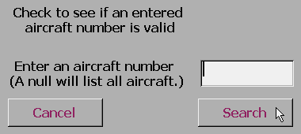
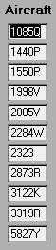

Figure 3 Valid AC Number Input
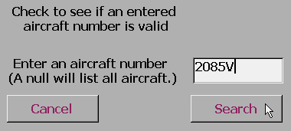

Figure 4 Output: Matching AC Number
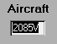

Figure 5 Invalid Aircraft Number
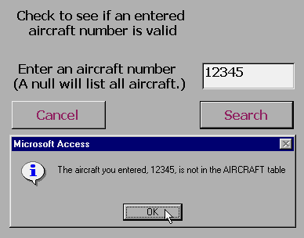

Note the Message box with the input return

Figure 6 Any Aircraft Number That Contains a “2”
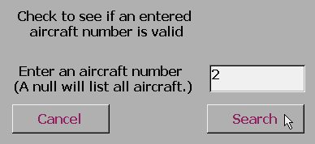
Figure 7 Output Includes all Aircraft Numbers
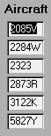
That Include a “2”

To make the I/O sequences shown in Figures 1 through 7 work, we’ll use the following application components:

- A form, named frmFindAircraftNumbers, to let the end user input the aircraft number. This form will use the following components:

  - An unbound textbox, named txtAircraftNumber, to receive the end user input.
  - An unbound – and hidden – textbox named Flag. This textbox will be used to temporarily store the aircraft number (AC_NUM) search results. If the search yields no records, the flag will be null.
  - Two command buttons, named CancelButton and SearchButton, respectively. The “On Click” property for the Cancel button will trigger a macro named mcrTemp.Cancel. The “On Click” property for the Search button will trigger a macro named mcrTemp.CheckAC.

- A parameter query, named qryAllAircraftNumbers, to retrieve the requested aircraft numbers. This query will use the end user input placed on the frmFindAircraftNumbers form as its search parameter.

- A form, named frmAllAircraftNumbers(Test), to present the output. The form’s data source is the qryAllAircraftNumbers query.

- A macro group, named mcrTemp, that contains three macros: CheckAC, Max, and Cancel.

These components are presented in Figures 8 through 11.

Figure 8 The Query
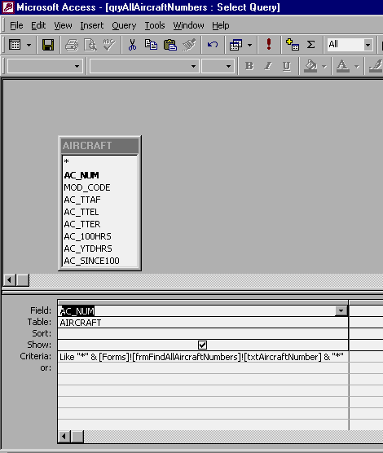

Figure 9 The Form Named frmFindAircraftNumbers
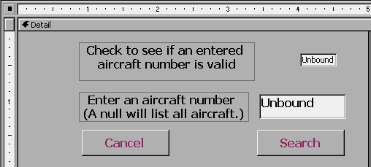

Unbound text box names:

Flag (hidden mode)

txtAircraftNumber

CancelButton SearchButton
(Command Buttons)

Figure 9A The CancelButton’s On Click Property
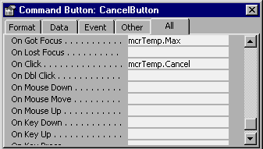
Figure 9B The SearchButton’s On Click
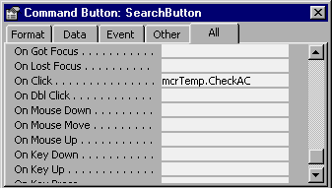
Property

Figure 10 The Form Named frmAllAircraftNumbers(Test)
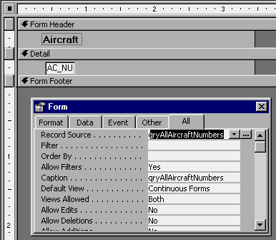

Note the record source

Figure 11 The mcrTemp Macro Group
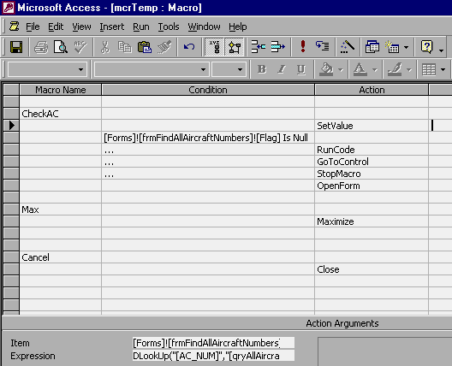

Table 1 Error Trap Macros, Their Actions, and Their Action Arguments

Macro Name Condition Action Action Argument

CheckAC
Set Value Item: [Forms]![frmFindAllAircraftNumbers]![Flag]
Expression: DLookUp("[AC_NUM]","[qryAllAircraftNumbers]")

[Forms]![frmFindAllAircraftNumbers]![Flag] Is Null
… RunCode Function name: MsgBox("The aircraft you entered, " &
[Forms]![frmFindAllAircraftNumbers]![txtAircraftNumber] &
", is not in the AIRCRAFT table" ,64)
… GoToControl Control Name: txtAircraftNumber
… StopMacro

OpenForm Form Name: frmAllAircraftNumbers(Test)
View: Form
Window Mode: Normal

Max
Maximize

Cancel Close Object Type: Form
Object Name: frmFindAllAircraftNumbers
Save: Prompt

